- THE SALVAGE NEPA PROCESS

Here’s the link to the agency’s page with project docs: https://landbetweenthelakes.us/projects/

Two tornados passed across the LBL- one on the far KY end and the other on the far TN end:

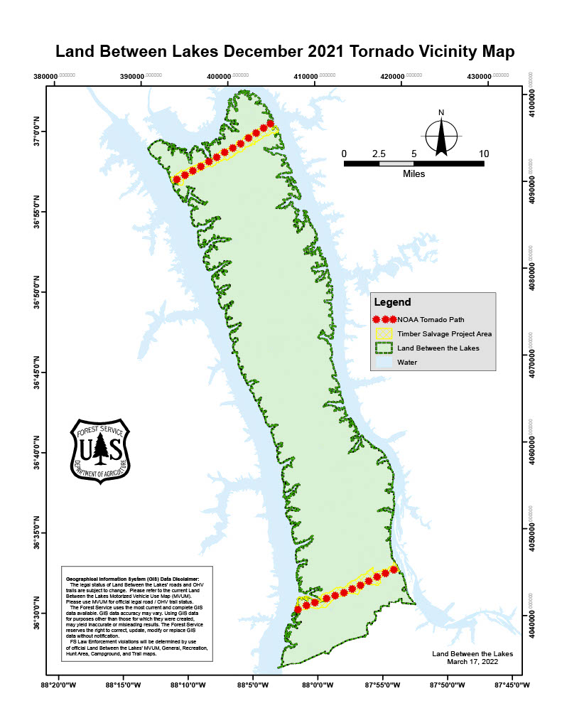

The salvage is broken into several sales. North End:
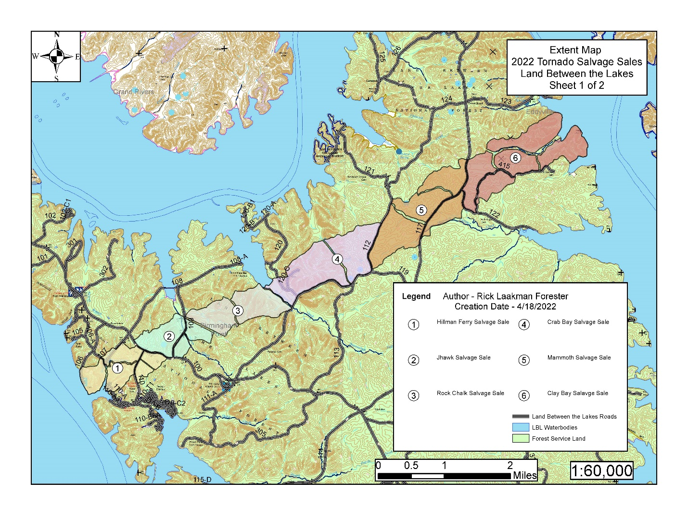
South End:

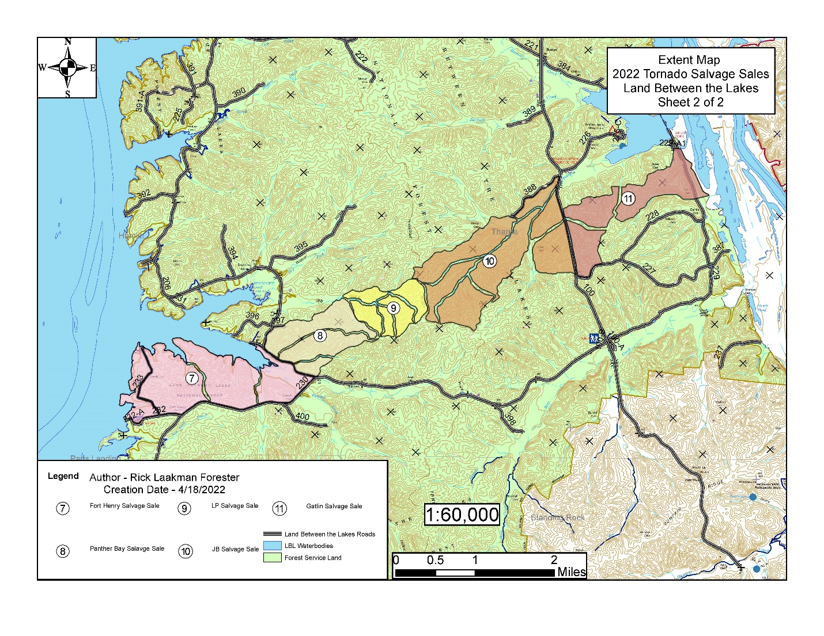
The NEPA process for this was pretty bad. Rather than go into detail here, I’ll include a letter that was sent to the Regional office in Atlanta that goes how the agency buried the public comment period. The number of dishonest things Westbrook et al in is breathtaking:

February 8, 2023 212 Greenleaf St. Chattanooga, TN 37415 www.tennesseeheartwood.org

John Westbrook Environmental Stewardship Manager Land Between the Lakes National Recreation Area Golden Pond Visitor Center
238 Visitor Center Drive
Golden Pond, KY 42211
Dear Ranger Westbrook, et al:
On behalf of the Tennessee Chapter of the Sierra Club, Tennessee Heartwood, and Heartwood, I wish to submit the following concerns and suggestions to the Land Between the Lakes National Recreation Area (LBL). Members of the Tennessee Chapter of the Sierra Club and Tennessee Heartwood use the LBL, including the forest that encompasses the Tornado Salvage Area, for a wide range of uses, including hiking, fishing, hunting, camping, wildlife watching, and other recreation activities. We take an active interest in the management of this forest and offer the following comments in the spirit of good management of our public lands in Tennessee and Kentucky. Furthermore, both groups are committed to transparency and the full implementation and spirit of public participation and disclosure processes that are found in the National Environmental Policy Act (NEPA).
Public Involvement
While we have been concerned about public involvement at the LBL for quite some time, they have become even greater because of Mr. David Nickell (Coalition for the Preservation of the Land Between the Lakes) recently sharing with us his correspondence with you. We must say that we are concerned about matters of protocol and public outreach at the Land Between the Lake. These concerns include procedures for promulgating NEPA processes, public meetings, access to information, and consistency in maintaining publicly available documents.
We have interacted with the Forest Service across districts all over Regions 8 and 9 for over 25 years and can say that we have a basic understanding of agency standards. We have not seen a district that failed to do the following:
- Solicit and maintain a mailing list of interested individuals and organizations who wish to be kept informed of NEPA-level (National Environmental Policy Act) proposals, processes, and decisions- and to actively use that list.
- Promulgate a Schedule of Proposed Actions (SOPA) that is kept on their official website and sent upon publication to their mailing list.
- Publish and release to the public NEPA-level proposals on the day that they enter record.
- Have a public comment period for NEPA proposals that is of an adequate time frame.
- Have a Record of Decision (ROD) that appears after public comment that is consistent with its stated public comment period with the Scoping Notice.
- Have consistency in the publishing of notices and comment periods across its online platforms.
- Provide access to core management information and maps to aid the public in making informed, site-specific comments on NEPA-level actions.
After hearing from Mr. Nickell and reviewing your website, your Facebook Page, and other publicly available sources, as well as in past interactions, we can conclude that the LBL could work better at complying with these standards.
We recall well our meeting with you when you first came to the LBL years ago to talk about lines of communication and trust. We wish that this were the case, but there are significant things lacking.
We wish to address some of the problems that are clearly happening with public communication and comments. Our concerns can be wrapped up in the statement The Land Between the Lakes needs to be following the standard procedures of the Forest Service in the interests of professionalism and public accountability.
A corollary to this is that these agency standards have a very specific purpose, one that we have stressed over and over in meetings and public comment on both forest level and National level NEPA processes and rulemaking change: these standards are to ensure that regular, nonprofessional citizens have access to timely information and the ability to review and comment on that information that informs and affects agency policy.
“Regular, nonprofessional citizens” means people who have day jobs, who aren’t represented by credentialed professionals who know where to unearth this information on other sites, through backdoor channels, through closed stakeholder/collaborative meetings, or a FOIA. It means everyday people who aren’t part of approved “publics”/” stakeholders” who sometimes have vested financial interests in partnerships and stewardship contracts. This district’s manner of handling its disclosure and public comment goes against these principles. We will detail some of these concerns, often referencing Mr. Nickell’s correspondence with you that he has shared with us. We have verified the online materials that he cites.
We have the same questions as the ones that Mr. Nickell asked you on January 10. They are worthy an answer and future action:
· Why does the LBL not have standard announcements of individual projects sent to those who are on their mailing list that other districts do, as in the examples I have sent in my earlier letter?
· Why did the two communications that I have been able to find about the Tornado Salvage Scoping Notice not get sent out in time for those who would see them to even comment?
· Why does your scoping notice give ten days to comment, while your decision memos say that 30 days was given?
· What is the purpose and legality of conducting public comment periods in this way?
· What public comments were received? Those comments should be a matter of public record, but I cannot find any. Were any even submitted?

Mr. Nickell performed a valuable service here in bringing together the confusing, misplaced, and sometimes contradictory information issued by the district that is cited below. He furthermore has helped demonstrate to the LBL how other districts across the country are able to accomplish the mundane tasks of simply putting up proposals, analyses, supporting documents, and records of decision in a timely, standardized manner that people can use by forwarding them to the district. Please review these examples- they are the minimum of what the LBL should be doing. We also await answers to these questions.
Schedule of Proposed Actions (SOPA)
As Mr. Nickell has addressed, the LBL has not released a SOPA to its mailing list or on its official site in some time. You explained to him last year via phone that it was a case of “slipping through the cracks” due to COVID and changes in personnel, with nobody having yet “picked it up”. Nonetheless, COVID did not prevent other districts from doing their due diligence, and we all know that frequent personnel changes are a feature of this agency. What is curious is that one can go to National’s website, and a SOPA has been promulgated there all along. We restate Mr. Nickell’s question: what’s going on here?
Posting a SOPA on the agency’s website on the standard resource management page and sending it out to an updated mailing list needs no explanation or justification. We are now entering four years since SOPA was put on the LBL’s site and being sent to the mailing list, and it needs to restart.
Public comment period announcement and timeframe for the Tornado Salvage
As the screenshots Mr. Nickell has provided and we have verified show, the agency’s rollout of a scoping notice and comment for the Tornado Salvage is not to agency standards.
You wrote a scoping notice on March 21 (shown below in Mr. Nickell’s correspondence, along with other notices we will reference), saying that the public had 10 days to comment. Of course, no announcement of this notice was sent to any of the public that day. This would put March 31 as the due date.
Then on your Facebook page, an announcement is posted March 30 about a public comment, which would give anyone reading it a single day to write and submit something meaningful.
Then on a “What’s Happening at the LBL” mailout that Mr. Nickell nor any of the local citizens and officials he knows received, there is a mention of a public comment buried below other announcements. Unfortunately, this email was sent on April 8, after the deadline mentioned in the scoping notice- thus, anyone who would have gone to your website would have been automatically discouraged from commenting, as the deadline clearly is set for 10 days after March 21.
Then to make things more concerning, your record of decision says that the public was given 30 days to comment- a contradiction of the 10 days cited in the scoping notice.
We must say that this timeline reflects a lack of seriousness about public comment on this district. We can restate that in a quarter century of reviewing and participating in NEPA processes we have never encountered anything even remotely like this.
Regarding the reply to Mr. Nickell’s concerns by invoking “public safety” to explain the lack of procedure, the tornados took place in December 2021. The most pressing safety measures of clearing roads and other high traffic/public use areas had taken place by March 21, as is typical for an agency where salvage sale conditions from wildfire, tornados, and other natural events are unfortunate but quite common. The scoping notice of March 21 is a post-emergency document that is addressing what is a routine salvage sale that has largely devoted itself to going into the forest interior beyond high traffic areas to take out timber- which is a subject that we will address later.
Furthermore, regarding your statement to Mr. Nickell, you, Jim Scheff and Davis Mo[u]nger were the top of my list of contacts. At your convenience can you clarify if the basis of your question in regards to the SOPA was satisfied above, we cannot recall being contacted by your office.
More Information Makes for Better Communication
We also second Mr. Nickell’s repeated requests that LBL get more in line with other districts in providing key information about the agency’s forest and transportation systems. For example, Mr. Nickell has requested from the agency physical and electronic versions (Shapefile/KMZ/KML) of its roads system, its FSVEG database, and some of its special areas- in particular the “Core Areas” (another topic in itself that deserves its own discussion) designated a couple of decades ago. We and many of our colleagues in the conservation community have had little to no trouble getting all of these from forests as diverse as the Cherokee, Pisgah, Shawnee, Hoosier, and Chattahoochee and more. All these districts assume at least to some degree that the members of the public take seriously the agency’s request for relevant, site-specific public comment. Thus, these districts have no problem in making these important documents available to improve not only official public comment, but general formal and informal conversation. We and countless other organizations make use of these kinds of documents all the time and have on more than one occasion received thanks from land managers for pointing out important on the ground issues and opportunities that might otherwise have been missed. The LBL should do the same.
Why These Actions Matter
- Failure to have a consistent venue of outreach leaves people confused.
- Failure to have a full comment period with a coherent timeframe prohibits people from making public comments.
- Failure to make available core information on forest composition, roads, special areas, etc keeps the public in the dark, and often contributes to a district getting out of the habit of addressing key parts of its own mission due to the public acting as a sounding board and feedback source.
- Failure to gather public comment cuts off the agency from valuable long-term and up to date, site-specific information that it otherwise may have difficulty gathering on its own as an under- resourced agency.
- Failure to gather this information can result in ineffective policies or decisions that can have unintended consequences that later require expensive, time-consuming mitigation.
- Failure to follow the above invites cynicism and mistrust from the public and the media.
- Selective “outreach” that favors “approved” groups at the expense of the general public invites further mistrust.
Recommended Steps
We will restate Mr. Nickell’s recommendations and add some of our own. Once again, these are neither arcane, nor unreasonable, but reflect the current standards of the agency.
· The mailing list for those who have requested specifically to be informed about NEPA (National Environmental Policy Act) projects and analyses- whether they are at the EIS, EA, or CE level, as well as other significant analyses such as Watershed and Rapid Assessments- should be restored.
· These notices should be announced on the day that the formal comment period opens, if not ahead of time. This is because a comment period has no meaning if the period has not been announced when the clock starts.
· As there has been a significant amount of time since the SOPA and project list has been used, there needs to be announcements through all your communication outlets to encourage new sign ups.
· If other means of communication continue, such as the Facebook and “What’s Happening at the LBL” mailouts, project announcements need to be published at least by the day that comment periods open there as well. Consistency matters.
- The restarting of the SOPA as a part of the LBL website, as well as its announcement and publication to those on its mailing list and other media outlets needs to happen.
- It is time to honor requests for key agency information, including, but not limited to, the FSVEG maps, maps of the roads/transportation system, the designated “Core Areas” of the LBL, and Fire/Wildfire history.
- It is time for public meetings on agency actions that take place at times convenient for regular people who are otherwise constrained by their employment that isn’t that of an interest group. The agency used to take this seriously as a whole- offering both day and evening sessions so people with different timeframes would have an opportunity to participate.
- Significant NEPA actions should have field trips that allow people to talk to the agency on the ground- a weekend time frame is important if the agency is serious about engaging regular people who aren’t paid to come.
- Informal phone conversations have some utility, but they are not a substitute for written record.
- Public comment is an opportunity to engage. Our last comments to the district when it was worried about a supposed “oak decline” after an ordinary late frost in 2021 reflected on-the ground walk and analyses of the areas you were concerned about. We did not receive a response.
- The LBL has had a new Supervisor since Fall 2021. We encourage the Supervisor to hold a meet and greet or some similar outreach with the general public in keeping with precedent of previous Supervisors in getting to know the district better.
Further Considerations
We have had some concerns from Mr. Nickell and other members of the local community about the implementation of this salvage project and will probably have some upcoming questions in the near future.
The Tennessee Chapter of the Sierra Club and Tennessee Heartwood take a deep interest in the Forest Service’s Monitoring and Evaluation mission. We have made numerous recommendations over the last decade to the Cherokee in implementing M and E. This is an underappreciated, vital part of the Forest Service and supports a robust M and E program at the LBL. We will address this in a later communication.
We request a response to the concerns raised in the letter, and hopefully, significant reform. We look forward to the LBL operating in a professional manner that reflects well on the agency and serves the public trust. We look forward to moving ahead and contributing to good stewardship of the LBL. Thank you for your consideration.
Sincerely,
Davis Mounger
On behalf of the Tennessee Chapter of the Sierra Club and Tennessee Heartwood

Cc: Stephanie Lee Madson, Ken Arney, Rep. James Comer

Correspondence Between David Nickell and John Westbrook

- Nickell to Westbrook December 22, 2022

Re: tornado salvage and public communications

December 22, 2022
David Nickell
1079 US 60W
Ledbetter, KY 42058
John Westbrook
Land Between the Lakes National Recreation Area
Golden Pond Visitor Center
238 Visitor Center Drive
Golden Pond, KY 42211

Greetings:
I am checking in with you in regard to the current Tornado Salvage at the Land Between the Lakes and communications with the agency in general.

One of the reasons I have questions about the salvage in general is that I have not received communication beyond informal phone conversations, and I have a few questions about that as well. I not only have received no notice that a scoping and public comment period was happening for the Tornado Salvage but have not received a SOPA (Schedule of Proposed Actions) in several years. I first inquired about this as far back as 2019:
From: Nickell, David L (West Kentucky)
Sent: Friday, April 19, 2019 10:28 AM
To: comments-southern-land-between-lakes@fs.fed.us <comments-southern-land-between-lakes@fs.fed.us>
Subject: SOPA list

Sent from Mail for Windows 10
I used to receive regular SOPA list reports but have not gotten one for Land Between the Lakes in quite awhile. I would like to be re-added to the SOPA list for LBL. DavidL.Nickell@kctcs.edu

I received no response to this inquiry. I have discussed this with you since then, with the most recent communication being earlier this year on the phone after the tornado when you said that you were sorry that there hadn’t been a SOPA in some time due to a mixture of COVID and changes in personnel, and “nobody had picked up on it”, but that you would make sure SOPA reports were started again and make sure that I was added to the SOPA list.

It appears that SOPA has been assembled by “somebody” this entire time. Unfortunately, this has not been announced, nor does it currently appear on your website.
Here is a SOPA page for a Forest Service district that at least lists it:

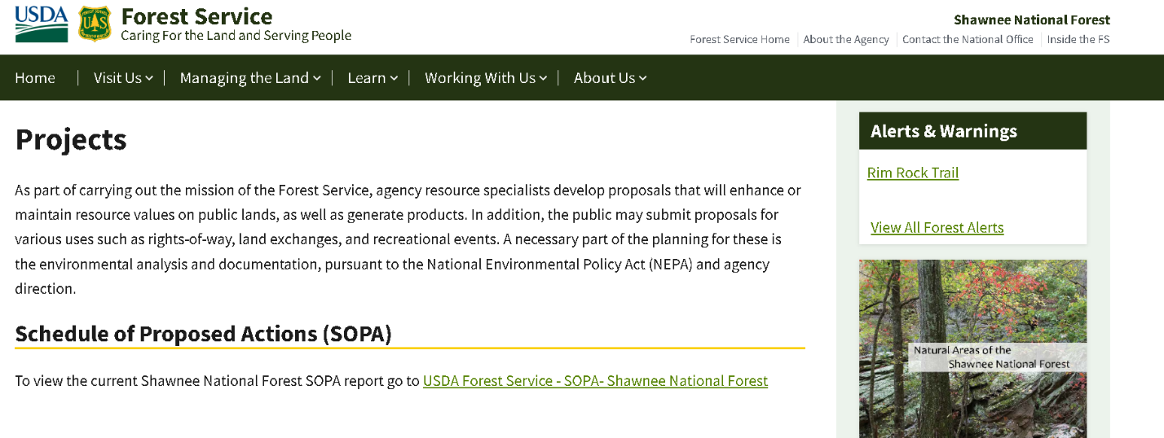
Here’s one from another district that adds a user-friendly map:
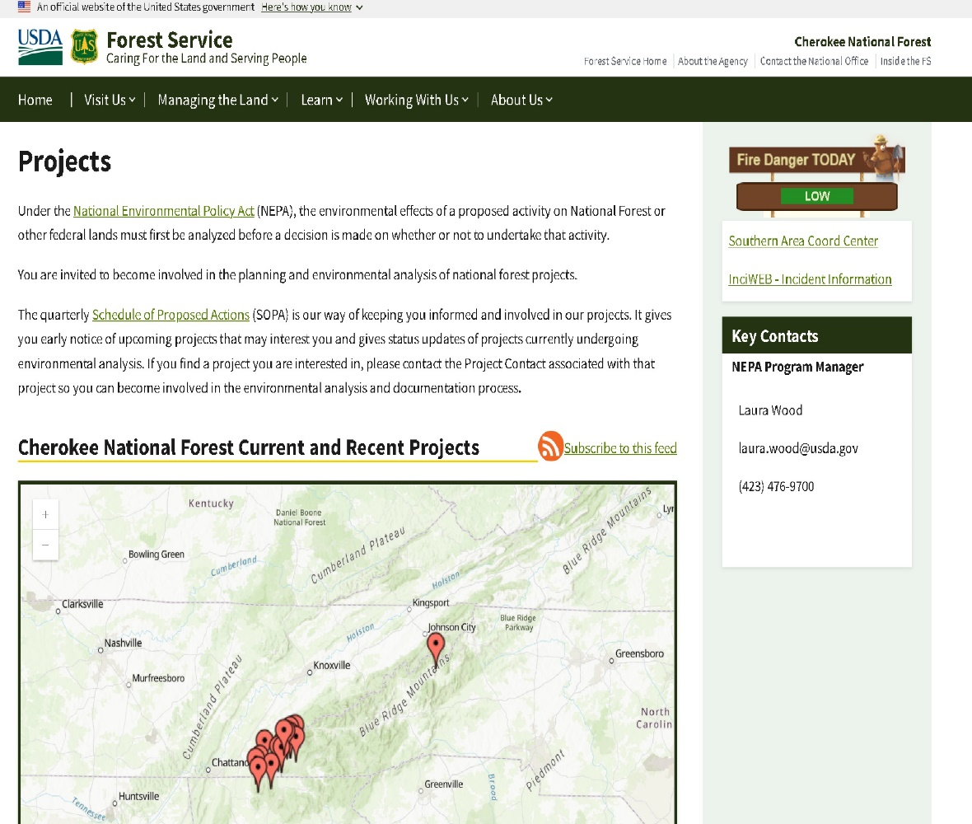

Even if there were no SOPA on your web page or being emailed, at least a good faith effort to announce that a project with a comment opportunity should be made, as in the case of the Tornado Salvage. Here is a project announcement email typical in the agency:

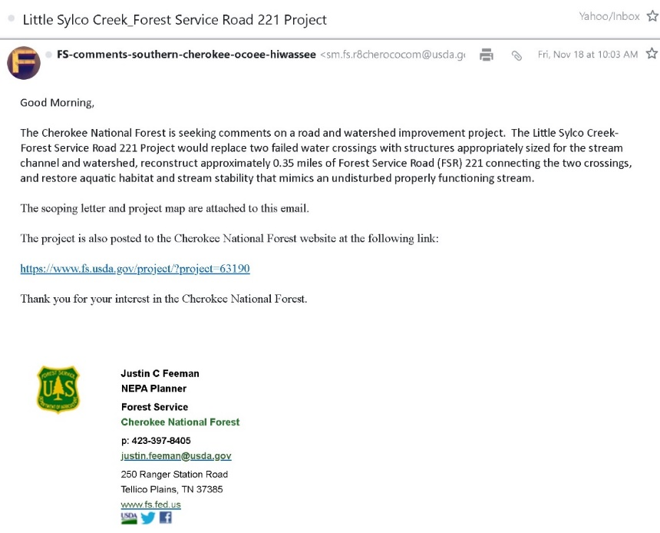

I am including these examples to show that such communications are standard for the agency and I request that the Land Between the Lakes act in this manner.
To reiterate, you told me in our most recent phone conversation that you were sorry that a SOPA hasn’t been promulgated by the LBL, with it “slipping through the cracks” due to COVID and changes in personnel, with nobody having yet “picked it up”.
An online search to see how other forests currently do their SOPA’s revealed that indeed the SOPA for the LBL has continued to be published here (screenshot below): https://www.fs.usda.gov/sopa/forest-level.php?110860
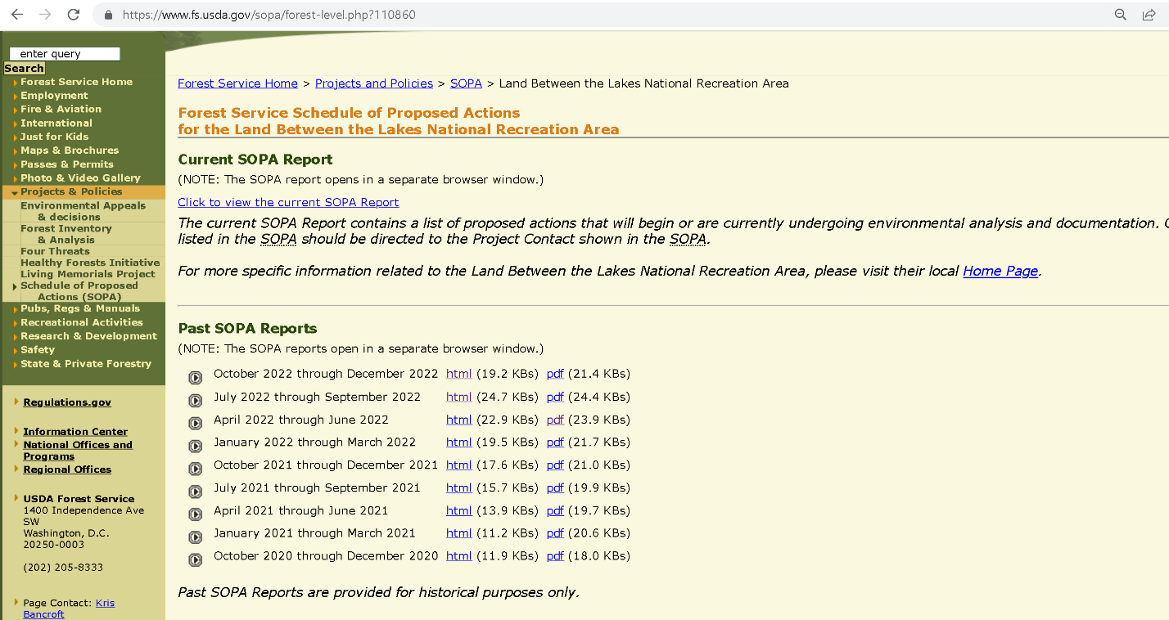
I am puzzled by this and find this to be troubling. Could you explain why the Quarterly SOPA is not on the LBL’s website and I have not been put on the list for its posting, despite repeated requests to be placed on it? Why was I told as recently as a few months ago that there hadn’t been a SOPA for years, when there clearly was one?
I also wish to know why I was not told of the public comment opportunity for the Tornado Salvage, when you told me clearly on our phone call that I would be kept abreast of updates? I have only seen the scoping and decision documents now because I had assumed our conversation that I would be “kept in the loop” (your exact words) about anything of substance happening with the salvage project.
Furthermore, an examination of the scoping notice and decision memos raises further questions about the commitment of this district to actively engage the public. The March 21 scoping notice for this project gives only 10 days for a public comment period:
How to Submit Comments
The Area Supervisor of LBL is the responsible official for this project. Based on the environmental analysis, Forest Plan direction, and the results of public involvement, the responsible official will decide whether or not to proceed with a specific action. Comments received in response to this solicitation will be considered part of the public record of this proposed action and will be available for public inspection. Comments submitted anonymously will also be accepted and considered; however, anonymous comments will not provide the agency with the ability to provide the respondent with subsequent information or environmental documents. Individuals or organizations wishing to comment are requested to do so within 10 days of the date of this letter.
On the other hand, the decision memos for both the south and north zone parts of this project state:
Public Involvement
This action was originally listed as a proposal on the LBLNRA Schedule of Proposed Actions and updated periodically during the analysis. The scoping period was initiated on March 21st, 2022 through April 19th, 2022. The scoping newsletter inviting public comment was sent to state, local governments, stakeholders, adjacent landowners, Native American Tribes and other interested persons.

This gives the impression that a typical 30 day comment period had been offered, when the scoping notice said otherwise. Other than the explanation of some “typo” rationalizing the inconsistency between the two, I wish to know why the scoping comment period was articulated in this way.

In our early 2022 phone conversation you said that you were contacting loggers to see who might be interested in bidding, but the agency was still in the process of figuring out where the work areas would be--there was no mention of an actual commentable document forthcoming from you. You said that you would be letting the public know as soon as the project details were pulled together and that I would definitely be kept in the loop.
I am concerned with the inconsistencies here and do not think that a “There was a public comment period” response will apply in this case, as I was acting in good faith based on conversations with you and trusting in what are standard agency procedures for communication (and were standard until four years ago at this forest). They have not been followed here and the actual documents on the Tornado Salvage themselves show a contradiction in the opportunity to comment at all.
As far as the project itself, you might recall the conversation from our conversation that you gave me assurances that the salvage project was meant to ensure public safety, and would mostly take place along roads and at high traffic places like campgrounds and trails. You further stated that no new roads would be built, with access being along existing roads by means of cabling. You also said that fallen and damaged trees would be taken.
Your decision memos affirm this purpose, “The timber salvage project is needed to remove damaged trees within the affected stands. This will include fallen trees and standing damaged trees. The primary purpose for removing damaged trees is for public safety,” with forest health and timber being secondary and tertiary benefits.

However, I have passed by some of the places where parts of the project have or are taking place and it appears that the taking of trees is occurring beyond the areas mentioned, and it looks like there are some roads that have been recently built into the forest interior. Since roads have been a topic of conversation I would like to know:
- What roads have been constructed or reconstructed in the scope of this project. I wish to see a map and a list of these roads and their distances.
- What roads have not yet been built or reconstructed that will be planned over the course of this project?
- Also, what is the plan for these roads in terms of future use or decommissioning and obliteration, and will any be added to the system’s inventory?
- Are there trees being taken that have not incurred significant damage?
- Are any trails being closed or rerouted to accommodate the loggers?
At this point, particularly in light of past meetings about the roads inventory and the need to decommission unneeded roads that do not provide access to cemeteries and other special sites, I request both hard and electronic (shapefile or kml/kmz) copies of the LBL’s road inventory in order to help me not only understand the scope of this project but for future dialogue on roads and access issues that have been longstanding points of discussion and will likely be in the future.
I can assure you that your response will be very helpful in articulating agency policy and will help in engaging the public- which, as this letter details, continues to be a challenge. I am hoping that the concerns listed here can be addressed in a way the brings the LBL more in line with agency norms and standards. Thank you for your consideration and your response.

From: Westbrook, John -FS <john.westbrook2@usda.gov>
Sent: Friday, December 30, 2022 8:37 AM
To: Nickell, David L (West Kentucky) <davidl.nickell@kctcs.edu>
Subject: RE: [External Email]Salvage Sale Questions

Morning sir and hope you are well today. I just wanted to close the loop and provide you some additional information gained yesterday afternoon on my way home. This is in regards to the location of the SOPA link on our website. It appears that the new USDA domain national website creators failed to migrate our materials over during the last few migrations. As such our material is in flux but is ready for posting as soon as they return to service. Our local web curator assured me that the national SOPA site is up and we are in the process of adding the national link to our local page. Hope this goes to further clarify and provide answers to the questions you have asked. If you have any further questions or just wanna talk about stuff in more detail, feel free to give me a call or shoot me an email. I remain willing to assist you in whatever manner works best for you, I just need to know what it is.

Thanks in advance…

- Westbrook responses December 22-29, 2022

From: Westbrook, John -FS
Sent: Thursday, December 29, 2022 2:17 PM
To: Nickell, David L (West Kentucky) <davidl.nickell@kctcs.edu>
Subject: RE: [External Email]Salvage Sale Questions

Good afternoon sir and hope you are well today. I will attempt to answer your questions at this time. I do however have a few qualifying questions mixed throughout to ensure that you are receiving the information that you have requested.

Schedule of Proposed Actions

“Is the question in regards to the reporting that is loaded at the national level thru the PALS system (consistent with my statement that no one on the local level has any role) or lack of a personal notice for the Emergency salvage cleanup efforts?”

All public notices were submitted to local officials, interested congressional delegates, and recognized Tribes. We published the request for comments on our website and Facebook pages during the required 10-day comment period. This was consistent with regional direction and the need for the immediate removal of storm damage on the unit. This process began in earnest the first week of January to capture the value of the downed timber and to lessen the impacts to our users. I made sure to personally call our known interested publics throughout various parts trigger points to ensure real time information was shared. Of which, you, Jim Scheff and Davis Monger were the top of my list of contacts. At your convenience can you clarify if the basis of your question in regards to the SOPA was satisfied above.

Roads

In regards to road construction or reconstruction now or during the life of the projects, the categorical exclusion that we used does not allow for the construction of nor the reconstruction of roads. Nor did we allow for anything along these lines. What you may be seeing are roads that are allowing “temporary” access to the interior parts of the areas impacted by the storm. By definition, these roads will be immediately decommissioned and naturally contoured after their purpose has been met (they are one time use only and are in areas already heavily impacted by the storm). The location of these roads due to their temporary nature has not and will not be captured on our Motor Vehicle Use Maps (MVUM). This ensures that they will not remain on the landscape after the sales are complete. We have designated seed mixtures and mitigative measures to expedite their blending back into the natural landscape as soon as possible. Due to their temporary nature, these roads are not predetermined by the FS. Their locations are agreed upon (and approved) as needed to gain access to other impacted areas. Often times they are moved or relocated to protect sensitive resources or cultural relics that may appear in the impacted areas. With this possible movement of needed components of the sales, it is expected that some trees that may not have been immediately damaged by the storm will have to be cut and removed.

If you are aware of any new permanent roads that have been illegally constructed by contractors please provide gps locations so we can get these remedied immediately.

Trails

In regards to potential impacts to trails. The only sections of trails that will be closed by the ongoing sales are those that have already been identified as impacted by the original storm last Dec. We will not be closing any trail sections that were not already closed for public safety. It is thru these efforts that we have been able to open sections of the North-South Trail that would have taken us years to clear out and make safe for public use. It has been our focus throughout this process to ensure that our forest users are minimally impacted by the salvage cleanup efforts.

As a point of clarity, are you requesting that all of our future correspondence be thru email from this point forward? I am asking so that I can make sure that the open, honest and clear communication be continued through the rest of this cleanup effort. Your response to this and the above question are imperative to our continued progress in mending fences and moving forward in a positive and transparent manner.

If you have any further questions about the activities associated with this effort please feel free to contact me thru the means that works best for you.

V/r

From: Nickell, David L (West Kentucky) <davidl.nickell@kctcs.edu>
Sent: Tuesday, December 27, 2022 1:20 PM
To: Westbrook, John -FS <john.westbrook2@usda.gov>
Subject: Re: [External Email]Salvage Sale Questions

Hi John,
I hope your holidays are going well and you are staying warm.

I am leaving very shortly for Mississippi and will be away from phone reception. I would appreciate written answers to my questions.

Thanks.

From: Westbrook, John -FS <john.westbrook2@usda.gov>
Sent: Tuesday, December 27, 2022 9:52 AM
To: Mowrey, Andrew - FS <Andrew.Mowrey@usda.gov>
Cc: Nickell, David L (West Kentucky) <davidl.nickell@kctcs.edu>
Subject: FW: [External Email]Salvage Sale Questions

Good morning sir and hope you are well today. Please ensure that David gets added to any new SOPA notifications that go out moving forward (he is copied on this email). I apologize for not getting his contact info to you sooner and take full responsibility for this not occurring to this point. David, I reached out to you to discuss your questions and welcome the chance to speak with you directly on them. If you have any questions in regards to this please feel free to give me a call.

Thanks in advance…

- Nickell to Westbrook January 10

From: Nickell, David L (West Kentucky)
Sent: Tuesday, January 10, 2023 2:37 PM
To: Westbrook, John -FS <john.westbrook2@usda.gov>
Subject: Let's try it this way

David Nickell
1/10/23

John Westbrook
Land Between the Lakes
Golden Pond, KY

Please forgive my slow response time on this. I did an extended retreat at a Zen monastery and had no access to cell coverage or internet. I returned to the rush of getting my classes ready for the new semester to begin. Your responses from your last correspondence are in italics.
This is in regards to the location of the SOPA link on our website. It appears that the new USDA domain national website creators failed to migrate our materials over during the last few migrations.
OK. I guess I’m a bit confused here, as from our conversation last year, you had mentioned that SOPA’s had not even been released over the last couple of years because of a lack of a staffer to “pick it up”, as in, it wasn’t being written at all. Please clarify here.
All public notices were submitted to local officials, interested congressional delegates, and recognized Tribes. We published the request for comments on our website and Facebook pages during the required 10-day comment period. This was consistent with regional direction and the need for the immediate removal of storm damage on the unit. This process began in earnest the first week of January to capture the value of the downed timber and to lessen the impacts to our users. I made sure to personally call our known interested publics throughout various parts trigger points to ensure real time information was shared. Of which, you, Jim Scheff and Davis Monger were the top of my list of contacts.
I would like to address your response. First, the Forest Service sends out notices on individual projects to those who have requested them on every district I am familiar with. I regularly receive SOPA notices from the Shawnee, Cherokee and Hoosier National Forest units. Why isn’t the LBL doing this?
Lots of people are not on Facebook and can’t be reasonably expected to check a district’s site daily. That’s why notices are sent out to their mailing list, which has not been functional at least since 2019 at the LBL. Secondly, regarding this: I made sure to personally call our known interested publics throughout various parts trigger points to ensure real time information was shared. Of which, you, Jim Scheff and Davis Monger were the top of my list of contacts.
When you talked to me on the phone, I wasn’t informed about any actual comment period. I was assured I would be “kept in the loop” as the plan came together. Furthermore, I have talked to Davis Mounger of Tennessee Heartwood and the Tennessee Chapter of the Sierra Club and he says that he did not get a call. He also looked in his past emails for communications about the salvage sale, and could only find this from April 9:

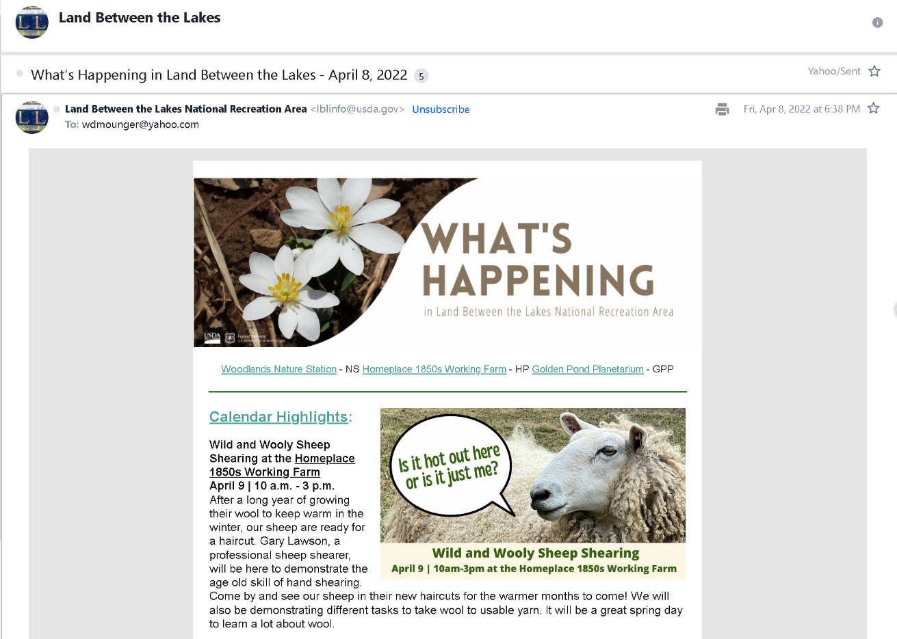

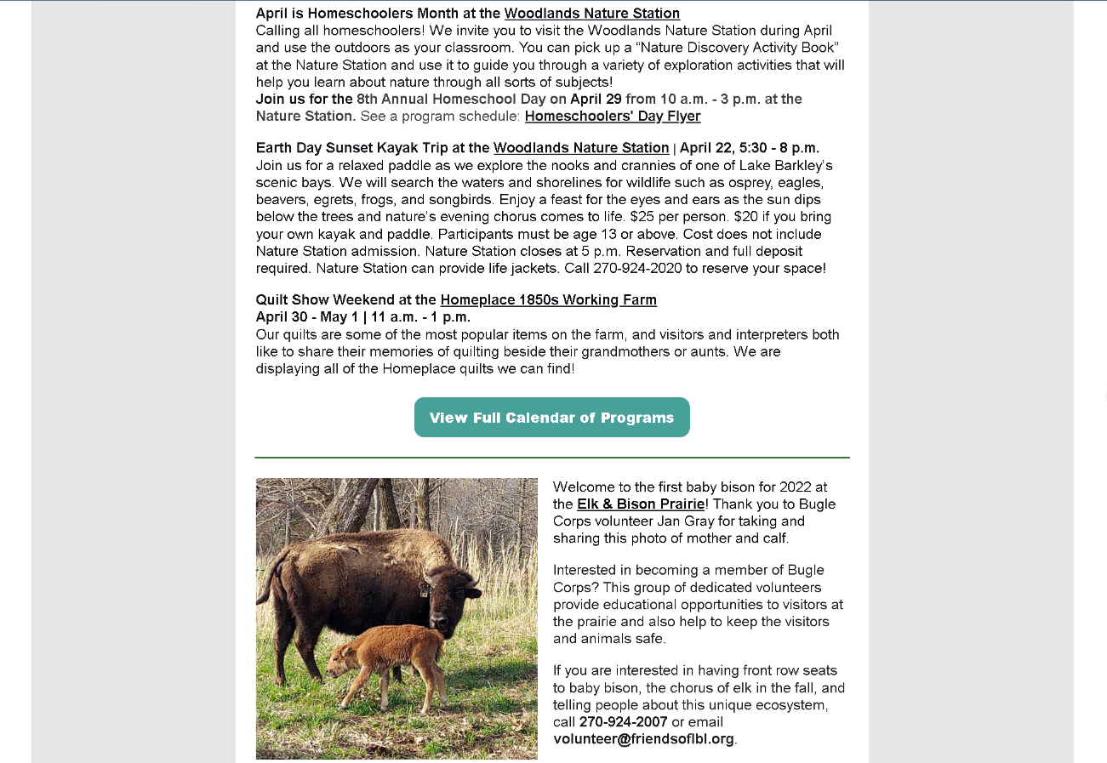

I did not receive this, for one. Also, along with the tornado salvage not even being in the subject line, there is something quite concerning: the date. It is buried deep in the message so that even if I had received it I might not have noticed it. Surely, a project this significant deserves its own dedicated correspondence.
From what it appears, this release that was your “public announcement” announced the projects and “how to submit public comments” after the 10 days that your scoping notice that began on March 21 was over.
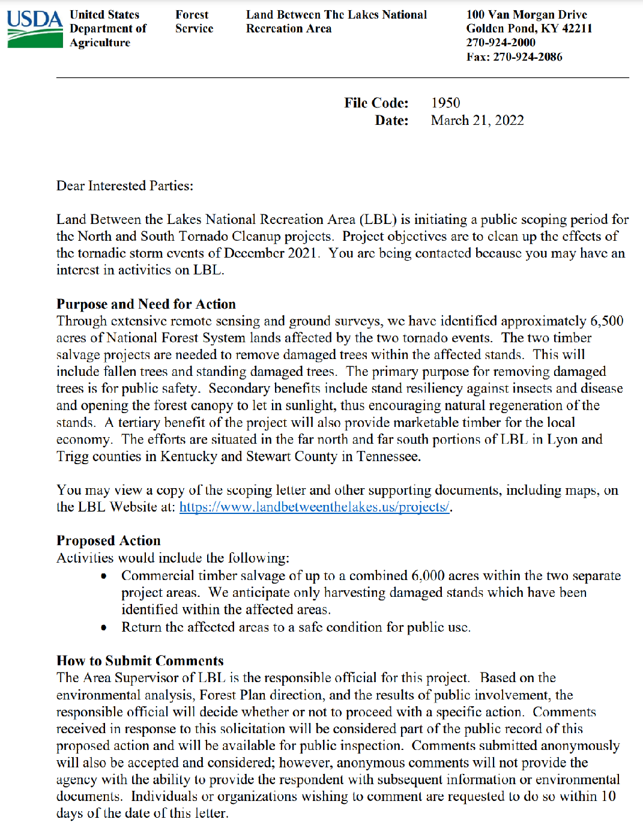

You confirm in your previous email that 10 days was indeed the time given. In other words, there was no opportunity to comment based on the time frames shown here. If this was the means of a public notice of this project, the public could not possibly submit a legal comment on this timetable.

Regarding your mention of the public opportunity to comment posting on your Facebook page, I assume you are speaking of this:
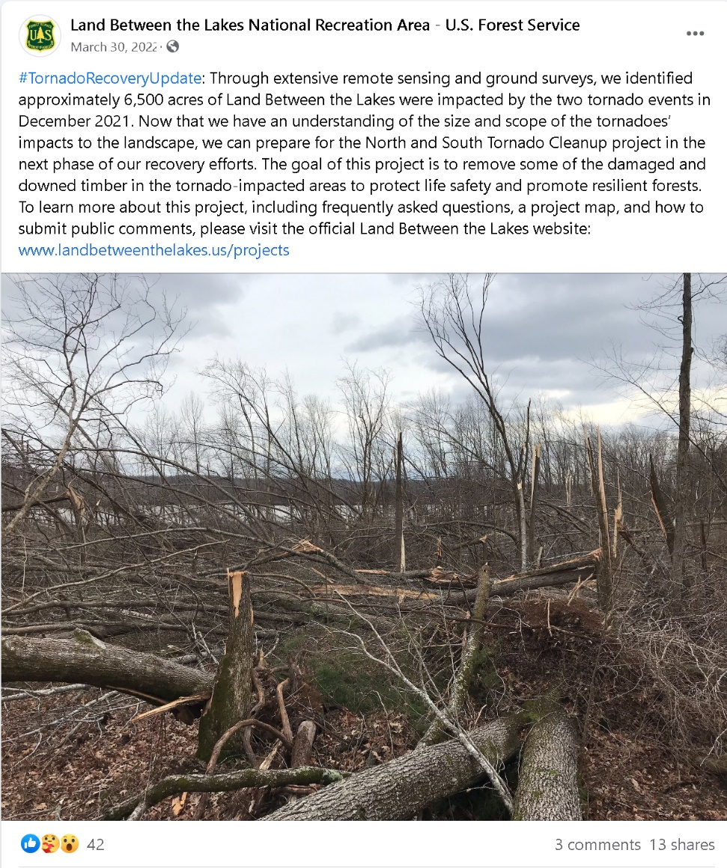

This is from March 30, which would have given anyone lucky to see this exactly one day to comment.
These examples, plus the still-unexplained matter of your decision notices claiming that a 30-day window was given for comment, underlies what has become a pattern that raises concerns about the district’s seriousness and commitment to public involvement.
This brings me back to some previous questions, and a few new ones:
· Why does the LBL not have standard announcements of individual projects sent to those who are on their mailing list that other districts do, as in the examples I have sent in my earlier letter?
· Why did the two communications that I have been able to find about the Tornado Salvage Scoping Notice not get sent out in time for those who would see them to even comment?
· Why does your scoping notice give ten days to comment, while your decision memos say that 30 days was given?
· What is the purpose and legality of conducting public comment periods in this way?
· What public comments were received? Those comments should be a matter of public record, but I cannot find any. Were any even submitted?

While I would like an explanation about why these things have happened, I also request that this district reinstate standard Forest Services procedures for public comment:
· The mailing list for those who have requested specifically to be informed about NEPA (National Environmental Policy Act) projects and analyses- whether they are at the EIS, EA, or CE level, as well as other significant analyses such as Watershed and Rapid Assessments- should be restored.
· These notices should be announced on the day that the formal comment period opens, if not ahead of time. This is for the reason that a comment period has no meaning if the period has not been announced when the clock starts.
· As there has been a significant amount of time since the SOPA and project list has been used, there needs to be announcements through all of your communications to encourage new sign ups.
· If other means of communication continue, such as the Facebook and “What’s Happening at the LBL” mailouts, project announcements need to be published at least by the day that comment periods open there as well.
· The restarting of the SOPA as a part of the LBL website, as well as its announcement and publication to those on its mailing list and other media outlets needs to happen.
These are not unusual or unreasonable requests, they are part of the standard procedures of Forest Service districts across the country. This is based on what I have seen and researched in looking at how other forests engage the public, but also in my discussions with conservationists who actively participate in National Forest policies. If the goal is to reduce public involvement at LBL, your current policies certainly appear to be effective.
Regarding roads, you say, In regards to road construction or reconstruction now or during the life of the projects, the categorical exclusion that we used does not allow for the construction of nor the reconstruction of roads. Nor did we allow for anything along these lines. What you may be seeing are roads that are allowing “temporary” access to the interior parts of the areas impacted by the storm. By definition, these roads will be immediately decommissioned and naturally contoured after their purpose has been met (they are one time use only and are in areas already heavily impacted by the storm).
How is what I am seeing not a road that has either been constructed or reconstructed? Yes, we know that the roads are for logging access. Does this “recontouring” mean obliteration and revegetation, with checks to make sure that invasive species have not taken hold? Please explain the mitigation planned more.
Furthermore, this seems a bit confusing” They are one time use only and are in areas already heavily impacted by the storm. While some of these access roads are close to extensive storm damage, there seem to be some, particularly on the south end, that go many hundreds of yards to get to an affected area. What was your criteria for acceptable road creation to get to what are some very interior parts of the forest? There were other points of access to the damaged areas that did not require road construction, and resulting logging of healthy, and very valuable, timber.
I have on at least two occasions provided you with a document prepared by a Forest Service planner leading up to the Forest Service’s initial Area Plan that identified two potential Roadless Areas in the south end of LBL. Did the road construction through undamaged forest impact those areas? Surely the public should have been informed of the potential long-term impacts on that potential.
Regarding this “With this possible movement of needed components of the sales, it is expected that some trees that may not have been immediately damaged by the storm will have to be cut and removed.” are you speaking of undamaged trees that are removed to clear the path for an access road? And in places where other access through the damaged forest was available. To what extent was the dollar value of those undamaged areas of forest a consideration in deciding where to put the new access roads? Shouldn’t that have been information available for public comment?
This brings me back to my request for a hard copy and a shapefile/kmz/kml electronic copy of the agency’s transportation system of inventoried and uninventoried roads. I would assume that they would reflect your inventory that the LBL made when it did its 2016 Travel Analysis Report. As I stated in my initial request, this information is important not only for understanding and discussing the matter of roads in the Tornado Salvage, but also for other current and future management policies and concerns. As we both know, roads make up a significant part of discussion between the agency and forest users due to their relevance in recreation, heritage, cemetery access, roadless and wild areas, invasive species, economics/budgeting, and more. The sooner we are literally “on the same” page discussing the same inventory, the more fruitful engagement with the public will be.
Regarding trails, such as the North South Trail, are any being repurposed as logging access roads? If so, where?
As a point of clarity, are you requesting that all of our future correspondence be thru email from this point forward? I am asking so that I can make sure that the open, honest and clear communication be continued through the rest of this cleanup effort. Your response to this and the above question are imperative to our continued progress in mending fences and moving forward in a positive and transparent manner.
That seems to be the best option, since verbal communication has been so ineffective. I have no issues with personal communication between us, either in person or by phone. But, when there is potential for contentious interaction over these sorts of issues, I would prefer that a written record be maintained so that there are no disputes later as to what was actually communicated.
Several of the points and requests that I’m outlining here really shouldn’t be seen as some trust-building, rectifying-things exercise. They are what a typical Forest Service district does. While there is the matter of my personal communication with the Forest Service, the agency’s inability to maintain communication with the greater public is far more the issue.
I notice that you use the term “publics” – a new coinage I sometimes hear from the agency, rather than the term “the public”, which implies the public at large. I have raised this concern with you in the past. The former seems to be analogous roughly to that agency’s use of “stakeholders”, which implies a mixture of citizens who sign up for the mailing list, local elected officials, tribes, and what is sometimes an arbitrary selection of interest groups--a small cross section, rather than the general public.
The distinction can make a difference in mindset about what is considered public engagement or public involvement that is supposed to be more than a formality. It may be indeed that at a certain point in time there may be only a few who actively seek out the opportunity to participate in NEPA-based processes, that level of involvement can wax and wane at unpredictable times. One action may not result in much involvement, while another may not only bring out great public interest, but important information from unexpected places that can be considered by the agency for better decision making. For this and other reasons (government transparency, taxpayer rights, bringing new participants into the fold, etc), it is considered good practice to at least honor the procedures that publicize agency actions, a good faith window of opportunity to respond, and adequate information for that involvement to happen.
As you are well aware, there has been tremendous public involvement in LBL management decisions in the past. Rather than taking actions designed to reduce that involvement, the agency should see the great interest in the proper management of LBL as a positive and should be encouraging it.

- Westbrook and Nickell January 10 and 12, 2023

From: Westbrook, John -FS <john.westbrook2@usda.gov>
Sent: Thursday, January 12, 2023 10:50 AM
To: Nickell, David L (West Kentucky) <davidl.nickell@kctcs.edu>
Subject: RE: Quarterly Schedule of Proposed Actions (SOPA) - January 2023

Morning sir and hope you are well today. I just wanted to get back with you to let you know that I am working my way thru your last email requests. As I gain some momentum and begin to accumulate materials, I will reach out to you to begin sending it out. As you are aware, there was a lot going on in the message and as such will take me a while to complete the task. If you have any questions between now and then, please feel free to reach out to me.

Thanks for your continued interest in our Lands Between the Lakes…

From: Nickell, David L (West Kentucky) <davidl.nickell@kctcs.edu>
Sent: Tuesday, January 10, 2023 11:07 AM
To: Westbrook, John -FS <john.westbrook2@usda.gov>
Subject: FW: Quarterly Schedule of Proposed Actions (SOPA) - January 2023

FYI, I received this today.

From: Mason, Marion - FS <marion.mason@usda.gov>
Sent: Tuesday, January 10, 2023 10:00 AM
Subject: Quarterly Schedule of Proposed Actions (SOPA) - January 2023

You don't often get email from marion.mason@usda.gov. Learn why this is important
Please find the schedule attached. Thank you for your interest in Hoosier National Forest.

Marion Mason, (she/her/hers)
(Certified Interpretive Guide)
Public Affairs Specialist
Forest Service
Hoosier National Forest
p: 812-276-4736
c: 812-277-6877
Marion.Mason@usda.gov
811 Constitution Ave.
Bedford, IN 47421
www.fs.usda.gov
Caring for the land and serving people

- Nickell to Westbrook Jan 17

Nickell, David L (West Kentucky) <davidl.nickell@kctcs.edu>
To:Westbrook, John D -FS
Tue, Jan 17 at 6:29 PM

From: FS-comments-eastern-shawnee <comments-eastern-shawnee@usda.gov>
Sent: Tuesday, January 17, 2023 4:42 PM
Subject: Shawnee Quarterly Newsletter -- January 2023

Please find our Shawnee Quarterly NEPA Newsletter and the Schedule of Proposed Actions for January 2023 attached.

One project is scoped in the January 2023 Shawnee Quarterly:
- River to River Trail Reroute at Cedar Lake

You are receiving this email message because you previously or recently expressed interest in being placed on the Shawnee National Forest electronic mailing list for “upcoming Forest projects and the Schedule of Proposed Action (of SOPA) electronically by mail”. As a member of this electronic mailing list you will 1) receive the Shawnee Quarterly distributed four times per year in January, April, July, and October; 2) be notified of project scoping notices not included in the Shawnee Quarterly; and 3) receive notification of signed decision documents. If you choose to be removed from this electronic mailing list and no longer receive the above listed project-related information, please send an email to comments-eastern-shawnee@usda.gov , subject line: Remove from Shawnee Projects Email List.

Terri Thomas
NEPA Planner
Forest Service
Shawnee National Forest, Hidden Springs/Mississippi Bluffs Ranger District
p: 618-833-8576 x105
f: 618-833-3693
terri.a.thomas@usda.gov
521 N. Main Street
Jonesboro, IL 62952
www.fs.fed.us

- David Nickell’s Feb. 1 response to Westbrook’s January 19 email

From: Nickell, David L (West Kentucky) <davidl.nickell@kctcs.edu>
Sent: Wednesday, February 1, 2023 12:38 PM
To: Westbrook, John - FS, KY <john.westbrook2@usda.gov>
Subject: [External Email]Deep Dive follow up

[External Email]
If this message comes from an unexpected sender or references a vague/unexpected topic;
Use caution before clicking links or opening attachments.
Please send any concerns or suspicious messages to: Spam.Abuse@usda.gov
Hi John,

I have deliberately delayed replying to your last email, just to let it sink in. The email in question is:
Westbrook, John -FS <john.westbrook2@usda.gov>





To:
- Nickell, David L (West Kentucky)
Cc:
- Mowrey, Andrew - FS <Andrew.Mowrey@usda.gov>
Thu 1/19/2023 10:46 AM
Good morning David and hope you are well today. We are in the process of doing a deep dive into the processes that were used during the multi-state emergency response efforts surrounding the tornados that impacted LBL in Dec. 2021. We recognize that there may have been some things done that were not and are not consistent with our normal operations on the unit. Once we complete this effort I will share those findings with you. Please understand that this dive will take into account the impacts of this emergency effort on the local, regional and state interests that were in play. And it will come from a position that public safety, plan consistency and area protections were driving the boat. Not any one issue or concern outweighed these factors. When there was a conflict between these, PUBLIC SAFETY took precedent. I’m sure we will find areas where we could have done things better or differently, but given the nature of the emergency we did what we were advised was necessary to move forward. With that being said, there is no need to send me any additional comment request pages from other units. I appreciate your continued interest in our Land Between the Lakes recreation area. Once this effort is complete you will receive a written response from me on our findings and on how we plan to resolve any perceived concerns. If you have any questions on the progress or status of this please feel free to reach out.

Thanks for your interest….

I had sent you SOPA reports and requests for comments from other National Forest units just to make my point that every other National Forest unit I deal with does follow the established procedure as laid out in NEPA requirements. LBL used to, but stopped several years ago, I assumed because the public involvement was not favorable to the controversial plans being proposed. Your response has left me with even more questions, having received no answers.

- You state that a "deep dive" is being undertaken to understand how the process broke down and how to correct it. Who will be doing the "deep dive" and what will the consequences be when the cause is found? Will LBL's management team be investigating itself?
- As stated above, I sent you a lengthy email, which included content from your emails and from other online posts, about the process and purposes for the salvage logging. I still have received no response to any of the questions I provided. But, several main questions remain that I do want answers to:
- You state repeatedly that the primary objective for the rushed salvage logging was public safety. Then why have roads of nearly a mile in length been built into the forest interior that was NOT damaged by the tornado in order to access the storm path? That path could have been followed without requiring the cutting of very valuable, healthy forest. Where the tornado path was nowhere near existing roads, trails, campgrounds, etc., how did that affect public safety?

- Why was the public not notified of an opportunity to comment on this project until the abbreviated comment period was nearly over? You state that this process had to be shortened because of the ongoing emergency. The emergency was just prior to and just after the tornadic event. All roads had been reopened already and trails rerouted or closed where necessary. The emergency was over! There was no need to bypass the standard procedures and exclude public involvement.
- I have on several occasions now provided you with the study done by LBL employees during the runup to the development of the current LBL Forest Plan. That study identified two areas in the south end of LBL which meet the qualifications for "roadless areas." That information was NOT included in the alternatives the public was allowed to comment on. When the Forest Service planner who did the study insisted that the public should have that information he was terminated. (He gave me the copy of that study.). I had asked before if the long, and very wide, roads being built through the undamaged forest interior to provide the loggers access to the storm path were through those potential roadless areas. I received no reply. If this was the case, surely that would have met the standards of requiring an impact statement and mitigation measures proposed for public comment.
- I requested the maps for the road inventory in LBL but have received no acknowledgement of that request. LBL is notorious for not having an inventory of the forest, not for species and I suspect not for the roads. How can you claim to be "managing" for improvement of forest health if you don't know what is currently in that forest?
- What oversight is being given to the loggers doing the work, and apparently targeting extensive areas of healthy forest in order to access the actual damaged timber? What oversight is being given to those who are supposedly "planning" these actions to ensure that the laws and regulations are followed? It is obvious that the public is not being allowed to know what is happening.
Please respond to my questions, provide the maps, and allow the public to know what is taking place. I have not taken these questions to the media or elected officials, yet, but that may prove necessary just to get a bare minimum response.

Sincerely,

David Nickell
1079 US Highway 60
Ledbetter, KY 42058

- From the Decision Memo for the Tornado Salvage
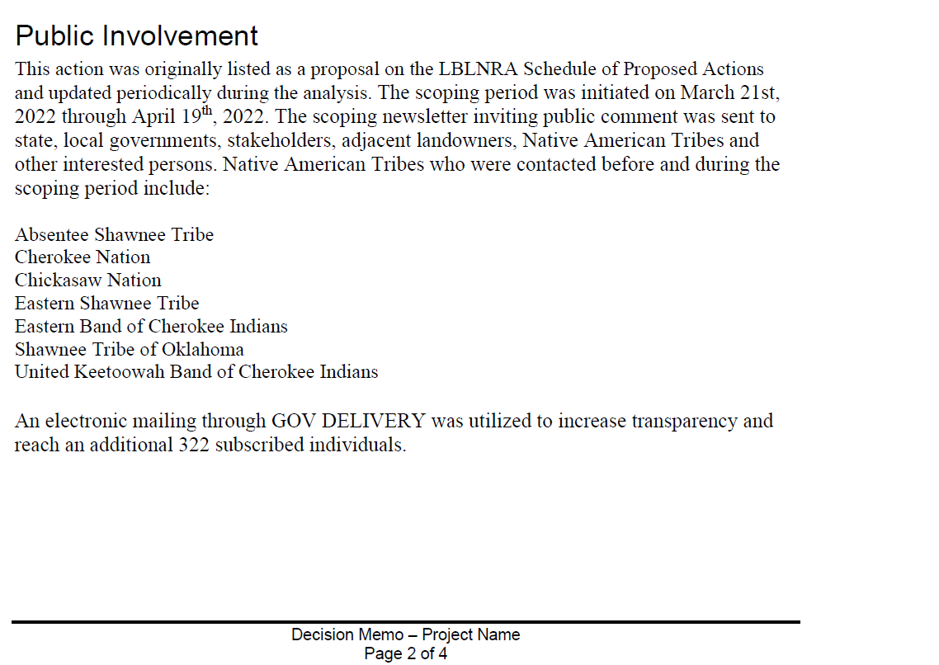

The district still won’t give any written explanations for this stuff.

- THE SALVAGE

We’ve been monitoring the sales on the ground and in the air with a drone. What we’re seeing:
- The north path was more severe and with more stand-replacement level knockdowns.
- The “emergency” provision that allowed for them to do a CE is being terribly abused. They originally said that it was for public safety, now Westbrook says that it was to avoid insect infestation, and, (he said this in person to a couple of people) “to avoid a catastrophic wildfire that would jump the lake [which is over half a mile across] and spread to the surrounding communities.
- They are allowing timber companies to determine what are damaged trees. As our footage will show, they are high grading the best timber in the adjacent areas to the tornado path.
- They are building new roads, which Westbrook said they won’t do, to the most remote parts of the forest to get timber.
- They are going against provisions of their management plan that say that at least 6 snags per acre need to be kept after a tornado salvage. Westbrook says they were granted an exemption from all regulations and plan standards because of the emergency.
- They are logging the Core Areas, which are wilderness-like areas that were designated in the management plan. The north tornado path has a lot of core area in it.

We have tons of pics and videos. Here are three to illustrate several of the issues.

There seems to be different tiers of logging going on here:
- Whatever true emergency there was got resolved in the weeks after the tornado: through roads, recreation areas, power lines
- There is the stand replacement level logging
- There is logging in adjacent areas that are “patchy” in the mosaic- overall there’s still 50-70 BA. What danger is here? Not only are fallen trees being taken, but some crews appear to be taking standing material
- There are some areas with only a damaged few fallen trees here and there that are getting pulled out, with good standing trees taken out also

The first video is on the eastern side of the north/KY tornado path. It covers at lot of issues at once, including logging in core areas, roads, etc. I have a map showing the drone path while I narrate.

https://www.dropbox.com/s/3ptmg0z1c5bymfp/east%20clay%20bay%20discussion.mp4?dl=0

The second one is in the Gatlin sale in the south/TN path. Clear example of going into the mostly undisturbed canopy to high grade timber.

https://www.dropbox.com/s/cdmxm8nocicnbb2/west%20side%20of%20gatlin.mp4?dl=0

The third one is to the west on the JP sale. Ground level to show once again the clear high grading:
https://www.dropbox.com/s/uastjffwthjs861/ground%20view%20discussion%20of%20jp.mp4?dl=0
We’ve got pics and footage from the other areas as well.

Besides not doing this kind of stuff, we feel strongly that the agency needs an EA or EIS to follow up what will happen to these areas next, and also to show that they can do a real, legally-compliant NEPA.

A few locals finally got a meeting with the agency. It did not go well. One account. These are elderly people who are trying to understand what is going on.

The meeting lasted nearly 3 hours. I just now got home. It was pretty frustrating.

J.B. Oakley, Donnie Holland, and Jim Wallace came. Jim has never wanted to confront the Forest Service (or TVA) on anything, but he and Donnie have been good friends since they were kids. Westbrook, Chris Joiner (their PR guy) and Donald Feagan (with their heritage program) were there.

They insisted I could not record the meeting because it would be subject to FOIA requests and would violate the rules of the Advisory Board, since the meeting was technically treading on their turf. It was BS from there on. I did take notes.

When I asked who came up with the plan, Westbrook said it was system wide. They sent the data to the regional office which developed the plan, and the Chief of the Forest Service signed off on it. The locals were only implementing it. The regional office sent in a silviculturist and "sale administrators," which is the first time LBL has ever had these. The sale administrators are supposed to check each logging site every day to make sure they are in compliance with the contracts. They can't give us copies of the contracts because they are proprietary.

He started out insisting they weren't building new roads, but only using old TVA roads. They were only reopening them. When I showed him photos and videos of new road construction, he said that those were only were the loggers needed them to access the storm damage. The Forest Service cannot tell the loggers where to put the roads because of liability issues, but when the loggers decide where to put them the Forest Service has to sign off on their placement and design.

As for the "emergency" that mandated bypassing normal NEPA processes, that wasn't about public safety, but about the fire hazard from the fuel load and insect/disease infestation from all the pheromones being released from all the damaged trees. The Health Emergency Preparedness and Response Administration (HEPRA) was activated in response to the storm, and that is what mandated the suspension of normal NEPA procedures. That includes suspension of all Core Area restrictions. They simply have no choice. That is why the CE was put in place.

As for the contradiction on the comment period lengths, Westbrook said that resulted from their NEPA guy accidentally posting the wrong dates. When I asked why they would not respond to requests for information he said it was because I insisted on everything being in writing. Instead of just being able to call and give me the information, it was now a formal request and had to go through bureaucratic processes that just took far longer because of the legal issues.

He emphasized over and over again that the fire hazard was just too great now to not do the salvage as rapidly as possible, and why the normal procedures are suspended. The number of snags and amount of fuel would make it too dangerous to send in a fire crew if a fire ignited. He kept referring to the fire at Gatlinburg and how one at LBL could easily jump the lake and burn the surrounding communities.

The contracts with the loggers classify the trees into categories: undamaged, moderate damage, extreme moderate damage, severe damage and catastrophic damage. Only the last three categories of trees can be cut, unless it is necessary to access the storm path. The loggers are making that determination, but the sale supervisors check them every day to make sure they are in compliance. The borders of the sale areas extend well beyond the storm path because it was too dangerous to send the people marking the boundaries into the damaged areas. Nothing that does not meet the categories of extreme moderate to catastrophic damage can be cut. I asked how they differentiated between moderate and extreme moderate. He said if 50% or less of the canopy was left it was extreme moderate. He said the trees in the videos that are still healthy but within the designated sale boundaries will not be cut.

As for the Core Areas, because Trump did an Executive Order removing all federal lands from the Man in the Biosphere program, those restrictions no longer apply. The Core Areas are still in the Management Plan, but any restrictions on when and why they declare that a threat of disease or infestation overrides the plan are gone. Therefore, the Core Areas must be "salvaged." As in all areas cleared, after a controlled burn removes the fuel debris, they will be sown in rye, clover and grasses. No trees will be replanted. The areas will be periodically reburned to maintain the clover and grasses. Part of the justification for this is that Potato Beans and other rare plants required disturbed areas and they may come back. That said, the areas are not being "removed" from their Core Area designation, just "temporarily withdrawn." Though the burning will probably prevent them from returning to forest. When Donnie asked if they were trying to establish Oak-Grassland habitat, Westbrook emphatically denied that.

The loggers are contracted to restore all roads to their original contours and reseed them in grass and clover. Those through the healthy forest will be allowed to return to trees on their own. The loggers are also required to remove all ruts, put in water bars on the hillsides and the whole area will be pristine again.

At Donnie Holland's insistence, another meeting was scheduled for April 24. Donnie and Jim Wallace thought the Forest Service is basically doing a good job, they just need to keep a closer eye on the loggers. J.B. didn't buy the BS, but he didn't speak up much.

Donnie is meeting with Coomer's staff this week and asked, toward the end of the meeting, how he should summarize my impressions of the meeting. I said I was terribly frustrated and felt like the main issues had not been addressed at all. J.B. did say that he couldn't help but notice that where they were putting the new roads and the loading decks always seemed to be in the areas with the highest value timber. He asked Westbrook if there were any trees in LBL that he didn't like. Westbrook said he would like to see all the maples and poplars gone. I took the opportunity to tell him that the whole maple incursion/oak decline they keep harping on is a lie. He didn't respond to that.

It was a frustrating meeting...

Donnie Holland, who is pretty close to Mitch McConnell, fortunately has changed his mind about the agency, and is trying to get some support from his office to try to rein these people in. David Nickell, who wrote this letter, has since had a meeting with the Between the Rivers group, and they are on board to try to stop the roads, the high grading, and to force the agency to comply with their management plan, among other things.

